* **Activity 7:**

Self-Join: Joining a Table to Itself

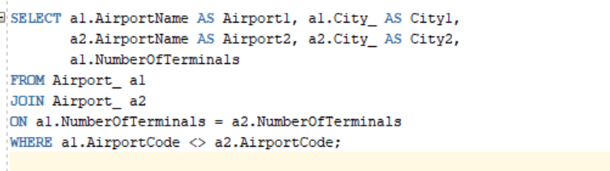

OUTPUT;

